Seahawk variants

**SH-60B Seahawk**

General information:

* 83% incommon with the UH-60A
* better engine
* single-stage [oleo](https://en.wikipedia.org/wiki/Oleo_strut) main landing gear
* Left side door replaced by fuselage structure, adding two weapon pylons
* Shifting tail landing gear 13 feet (3.96 m) forward.
* Larger fuel cells
* Electric blade folding system
* Folding horizontal stabilators for storage
* 25-tube pneumatic [sonobuoy](https://en.wikipedia.org/wiki/Sonobuoy) launcher on the left side (on the place where the aft window would be)

Sensors:

* towed [Magnetic Anomaly Detector](https://en.wikipedia.org/wiki/Magnetic_anomaly_detector) (MAD)
* air-launched sonobuoys (25 tubes)
* APS-124 search radar
* ALQ-142 ESM system
* Optional nose-mounted [Forward Looking InfraRed](https://en.wikipedia.org/wiki/Forward_looking_infrared) (FLIR)

Weapons:

* [Mk 46](https://en.wikipedia.org/wiki/Mark_46_torpedo)
* [Mk 50](https://en.wikipedia.org/wiki/Mark_50_torpedo) or [Mk 54 torpedo](https://en.wikipedia.org/wiki/Mark_54_MAKO_Lightweight_Torpedo)
* [AGM-114 Hellfire missile](https://en.wikipedia.org/wiki/AGM-114_Hellfire)
* AGM-119 Penguin missile
* [Rapid Airborne Mine Clearance System](http://www.northropgrumman.com/Capabilities/RAMICS/Pages/default.aspx) (RAMICS) using MK 44 Mod 0 30 mm canon

Single cabin-door mounted weapons:

* [M60D](https://en.wikipedia.org/wiki/M60_machine_gun#M60D)/[M240](https://en.wikipedia.org/wiki/M240_machine_gun) 7.62 mm (0.30 in) machine gun
* [GAU-16](https://en.wikipedia.org/wiki/M2_Browning#XM213.2FM213.2C_XM218.2C_GAU-15.2FA.2C_GAU-16.2FA.2C_and_GAU-18.2FA) .50 Cal (12.7 mm)

Crew:

* One pilot
* One ATO/Co-Pilot (Airborne Tactical Officer)
* An enlisted aviation warfare systems operator (sensor operator)

**SH-60F Oceanhawk**

General information:

* [Antisubmarine warfare](https://en.wikipedia.org/wiki/Anti-submarine_warfare) (ASW) aircraft
* Modified SH-60B

Sensors:

* AQS-13F dipping sonar
* 6-tube sonobuoy launcher (left side of the aircraft)

Weapons:

* [Mk 46](https://en.wikipedia.org/wiki/Mark_46_torpedo)
* [Mk 50](https://en.wikipedia.org/wiki/Mark_50_torpedo) or [Mk 54 torpedo](https://en.wikipedia.org/wiki/Mark_54_MAKO_Lightweight_Torpedo)

Fuselage-mounted machine guns (left side of the aircraft):

* [M60D](https://en.wikipedia.org/wiki/M60_machine_gun#M60D)/[M240D](https://en.wikipedia.org/wiki/M240_machine_gun#M240E1_and_M240D) 7.62 mm (0.30 in) machine gun
* [GAU-16](https://en.wikipedia.org/wiki/M2_Browning#XM213.2FM213.2C_XM218.2C_GAU-15.2FA.2C_GAU-16.2FA.2C_and_GAU-18.2FA) .50 Cal (12.7 mm)

Crew:

* One pilot
* One co-pilot
* One Tactical Sensor Operator (TSO)
* One Acoustic Sensor Operator (ASO)

**HH-60H Rescue Hawk**

General information:

* Model based of the SH-60F Oceanhawk
* Primary Combat Search And Rescue (CSAR), Naval Special Warfare (NSW) and Anti-Surface Warfare (ASUW) helicopter
* Carries various defensive and offensive sensors
* Engine exhaust deflectors providing infrared thermal reduction reducing the threat of heat-seeking missiles
* Used for MEDEVAC purposes and special operations missions

Sensors:

* [Forward Looking InfraRed](https://en.wikipedia.org/wiki/Forward_looking_infrared) (FLIR) with Laser designator
* Aircraft Survival Equipment (ASE) package
* [ALQ-144](https://en.wikipedia.org/wiki/AN/ALQ-144) Infrared Jammer
* AVR-2 Laser Detectors
* APR-39(V)2 Radar Detectors
* AAR-47 Missile Launch Detectors
* ALE-47 Chaff/Flare dispenser

Weapons:

* Four [AGM-114 Hellfire missile](https://en.wikipedia.org/wiki/AGM-114_Hellfire) on an extended wing using the M299 launcher and a variety of mountable guns including [M60D](https://en.wikipedia.org/wiki/M60_machine_gun#M60D), [M240D](https://en.wikipedia.org/wiki/M240_machine_gun#M240E1_and_M240D), [GAU-16](https://en.wikipedia.org/wiki/M2_Browning#XM213.2FM213.2C_XM218.2C_GAU-15.2FA.2C_GAU-16.2FA.2C_and_GAU-18.2FA) and [GAU-17/A](https://en.wikipedia.org/wiki/Minigun)

2 Door-mounted guns:

* [M60D](https://en.wikipedia.org/wiki/M60_machine_gun#M60D)
* [M240D](https://en.wikipedia.org/wiki/M240_machine_gun#M240E1_and_M240D)
* [GAU-16](https://en.wikipedia.org/wiki/M2_Browning#XM213.2FM213.2C_XM218.2C_GAU-15.2FA.2C_GAU-16.2FA.2C_and_GAU-18.2FA)
* [GAU-17/A](https://en.wikipedia.org/wiki/Minigun)

Crew:

* One pilot
* One co-pilot
* An enlisted Crew Chief
* Two door gunners

**MH-60R “LAMPS Mark III Block II Upgrade”**

General information:

* Converted from SH-60B
* Combined features from the SH-60B and SH-60F
* Pilot instrumentation is based on the MH-60S’s glass cockpit, using several digital monitors instead of the complex array of dials and gauges

Sensors:

* Aircraft Survival Equipment (ASE) package
* MTS-FLIR
* AN/APS-147 Multi-Mode Radar/IFF interrogator
* Advanced Airborne Fleet Data Link (AAFDL)
* And a more Advanced Airborne Active Sonar (AAAS)
* AN/APS-153 Multi-Mode Radar with Automatic Radar Periscope Detection and Discrimination (ARPDD) capability (After mid-life technology insertion project)

Weapons:

* [Mk 54 air-launched torpedoes](https://en.wikipedia.org/wiki/Mark_54_MAKO_Lightweight_Torpedo)
* [AGM-114 Hellfire missiles](https://en.wikipedia.org/wiki/AGM-114_Hellfire)

Crew:

* One pilot
* One co-pilot
* Other sensor personnel (no information on wikipedia)

**MH-60S Knighthawk**

General information:

* Based on the UH-60L
* Has many SH-60 features
* Main fuselage of the UH-60, with large sliding doors on both sides
* Single aft-mounted tail wheel
* Used for vertical replenishment, MEDEVAC, CSAR, ASW, CAS, maritime interdiction, intelligence, surveillance and reconnaissance, and special warfare support
* Four digital monitors in the glass cockpit
* A “batwing” Armed Helo Kit can be mounted on both sides to accommodate Hellfire missiles, Hydra 70 2.75 inch rockets, or larger guns

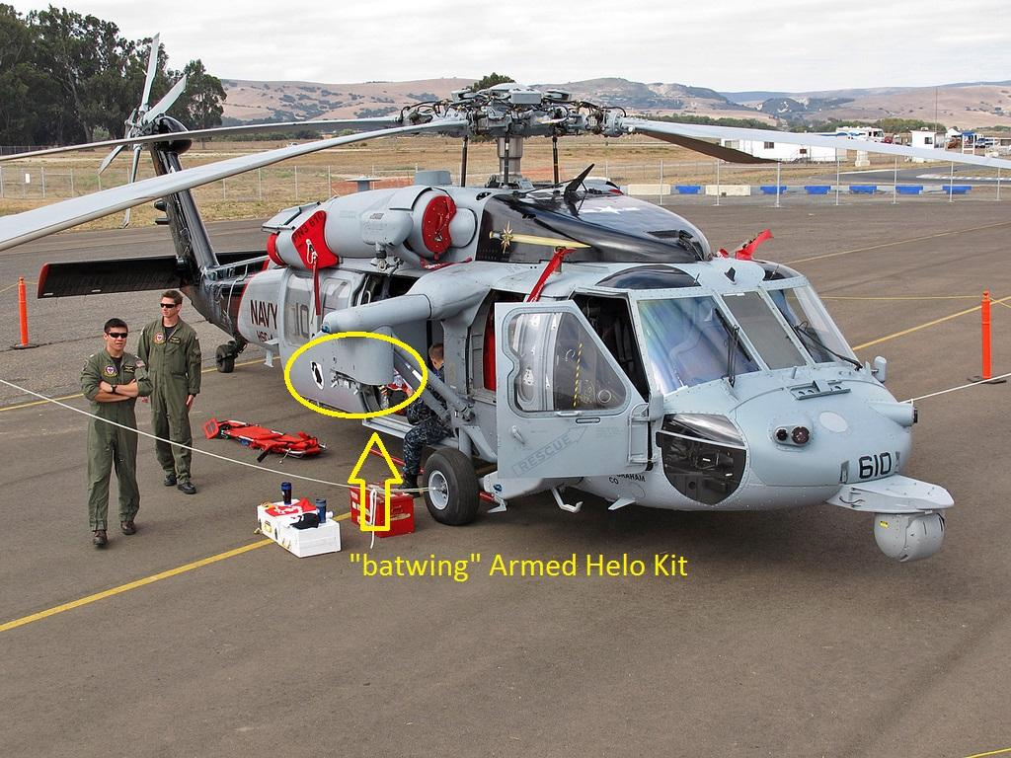

* Can be equipped with a nose mounted FLIR turret to be used in conjunction with Hellfire missiles

Sensors:

* Optional nose-mounted Forward Looking InfraRed (FLIR) turret
* AQS-20A Mine Detection System (MDS)
* Airborne Laser Mine Detection System (ALMDS) for identifying submerged objects in coastal waters
* ALQ-144 InfraRed Jammer (IRJ)

Weapons:

* When Armed Helo Kit mounted: 4 Hellfire missiles per hardpoint, Hydra 70 2.75 inch rockets, or larger guns

Door-mounted guns on both sides:

* M60D
* M240
* GAU-17/A

Crew:

* One pilot
* One co-pilot
* Two door gunners

Additional information:

* Airborne Laser Mine Detection System (ALMDS) is designed to detect, classify, and localize floating and near-surface moored mines
* The ALMDS beams a laser into the water to pick up reflections from things it bounces off of, then uses that data to produce a video image for technicians on the ground to determine if the object is a mine

**MH-60T Jayhawk**

General information:

* Developed from SH-60 Seahawk
* Went through MH-60T upgrade program, all HH-60J Jayhawk’s were upgraded to MH-60T Jayhawk
* Glass cockpit
* Airborne use of force package, including: both weapons for firing warning and disabling shots and armor to protect the crew from small arms fire

Sensors:

* Enhanced electro-optic/InfraRed sensor system
* Radar sensor system
* Airborne use of force capability

Weapons:

* 1 x 0.308 in (7.62 mm) [M240H](https://en.wikipedia.org/wiki/M240_machine_gun#M240E5.2FM240H) (starboard door)
* 1 x 0.50 in (12.7 mm) [Barrett M82](https://en.wikipedia.org/wiki/Barrett_M82)

Crew:

* One pilot
* One co-pilot
* Two flight crew